Simulation-Based Electromagnetic Analysis of TEM, TE and TM
Propagation Modes in Microwave Transmission Structures

Aim
To simulate and analyze TEM, TE and TM propagation modes in microwave transmission structures, and to calculate the cutoff frequencies and propagation behavior of a rectangular waveguide operating at 10 GHz.

Objectives
- Understand the differences between TEM, TE and TM propagation modes.
- Calculate cutoff frequencies for selected modes of a WR-90 rectangular waveguide.
- Determine whether each mode propagates or is below cutoff at the operating frequency.
- Plot representative transverse field patterns for TE10 and TM11 using MATLAB.
- Relate the calculated results to microwave waveguide operation.

Procedure
1.Open MATLAB and create a new script.
2.Enter the operating frequency and waveguide dimensions from the input table.
3.Convert GHz and millimetres to SI units (Hz and metres).
4.Calculate the TE10 and TM11 cutoff frequencies.
5.Compare each cutoff frequency with the operating frequency.
6.Calculate the TE10 propagation constant and guide wavelength.
7.Run the script and inspect the command-window results and field-pattern plots.

Theory
For an air-filled rectangular waveguide, the cutoff frequency of TE_mn or TM_mn is fc = (c/2) × sqrt((m/a)^2 + (n/b)^2), where c is the speed of light, a and b are the waveguide width and height, and m and n are mode indices. For TE10, fc = c/(2a). A mode propagates when f > fc and is below cutoff when f < fc.
A hollow, single-conductor rectangular waveguide does not support a TEM mode. TEM propagation is supported by structures such as coaxial cables and parallel-plate lines.
Above cutoff, the phase propagation constant is β = (2πf/c) × sqrt(1 − (fc/f)^2). The formulas assume an air-filled, perfectly conducting waveguide and neglect losses.

Input Parameter Table
S. No. | Input Parameter | Symbol / Setting | Value to Enter | Unit
1 | Operating frequency | f | 10 | GHz
2 | Waveguide width | a | 22.86 | mm
3 | Waveguide height | b | 10.16 | mm
4 | Waveguide length | L | 100 | mm

MATLAB Code
clc;
clear;
close all;
c = 3e8;
f = 10e9;
a = 22.86e-3;
b = 10.16e-3;
x = linspace(0,a,50);
y = linspace(0,b,50);
[X,Y] = meshgrid(x,y);
TEM = ones(size(X));
TE10 = cos(pi*X/a);
TE11 = cos(pi*X/a).*cos(pi*Y/b);
TM10 = sin(pi*X/a);
TM11 = sin(pi*X/a).*sin(pi*Y/b);
fc_TE10 = c/(2*a);
fc_TE11 = (c/2)*sqrt((1/a)^2+(1/b)^2);
fc_TM11 = (c/2)*sqrt((1/a)^2+(1/b)^2);
k0 = 2*pi*f/c;
beta = k0*sqrt(1-(fc_TE10/f)^2);
fprintf('TE10 Cutoff Frequency = %.2f GHz\n',fc_TE10/1e9);
fprintf('TE11 Cutoff Frequency = %.2f GHz\n',fc_TE11/1e9);
fprintf('TM11 Cutoff Frequency = %.2f GHz\n',fc_TM11/1e9);
fprintf('TE10 Propagation Constant = %.2f rad/m\n',beta);
figure;
subplot(2,3,1);
surf(X,Y,TEM);
title('TEM Mode');
xlabel('X'); ylabel('Y'); zlabel('Field');
shading interp;
subplot(2,3,2);
surf(X,Y,TE10);
title('TE10 Mode');
xlabel('X'); ylabel('Y'); zlabel('Field');
shading interp;
subplot(2,3,3);
surf(X,Y,TE11);
title('TE11 Mode');
xlabel('X'); ylabel('Y'); zlabel('Field');
shading interp;
subplot(2,3,4);
surf(X,Y,TM10);
title('TM10 Mode');
xlabel('X'); ylabel('Y'); zlabel('Field');
shading interp;
subplot(2,3,5);
surf(X,Y,TM11);
title('TM11 Mode');
xlabel('X'); ylabel('Y'); zlabel('Field');
shading interp;
subplot(2,3,6);
plot(x,ones(size(x)),'LineWidth',1.5);
hold on;
plot(x,cos(pi*x/a),'LineWidth',1.5);
plot(x,sin(pi*x/a),'LineWidth',1.5);
title('Mode Comparison');
xlabel('X (m)');
ylabel('Normalized Field');
legend('TEM','TE10','TM10');
grid on;

Output Parameter Table
S. No. | Output Parameter | Symbol | Calculated Value | Unit /  Interpretation
1 | TE10 cutoff  frequency | fc,TE10 | 6.562 | GHz
2 | TM11 cutoff  frequency | fc,TM11 | 16.42 | GHz
3 | Operating frequency | f | 10 | GHz
4 | TE10 propagation  constant | βTE10 | ≈ 158.0 | rad/m
5 | TE10 guide  wavelength | λg | ≈ 39.8 | mm
6 | TE10 propagation  status | f > fc | Propagating | 10 GHz  GHz | > | 6.562
7 | TM11 propagation  status | f < fc | Below cutoff | 10 GHz  GHz | < | 16.42
8 | TEM mode in hollow rectangular waveguide | — | Not supported | Requires suitable multi-conductor structure

Expected Output
The MATLAB command window reports cutoff frequencies, the TE10 propagation constant, guide wavelength and waveguide length. Two contour plots show representative scalar transverse patterns: TE10 varies across the broad dimension, while the TM11 pattern varies in both transverse dimensions. These are illustrative scalar patterns, not full vector electromagnetic field solutions. At 10 GHz, TE10 propagates and TM11 is below cutoff.
OUTPUT/ GRAPH :
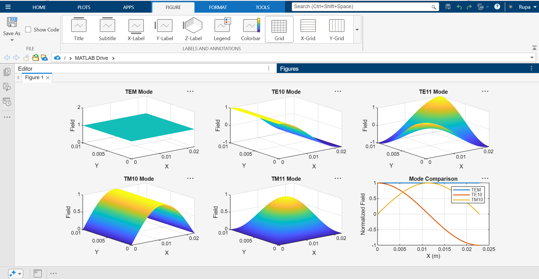

Calculations
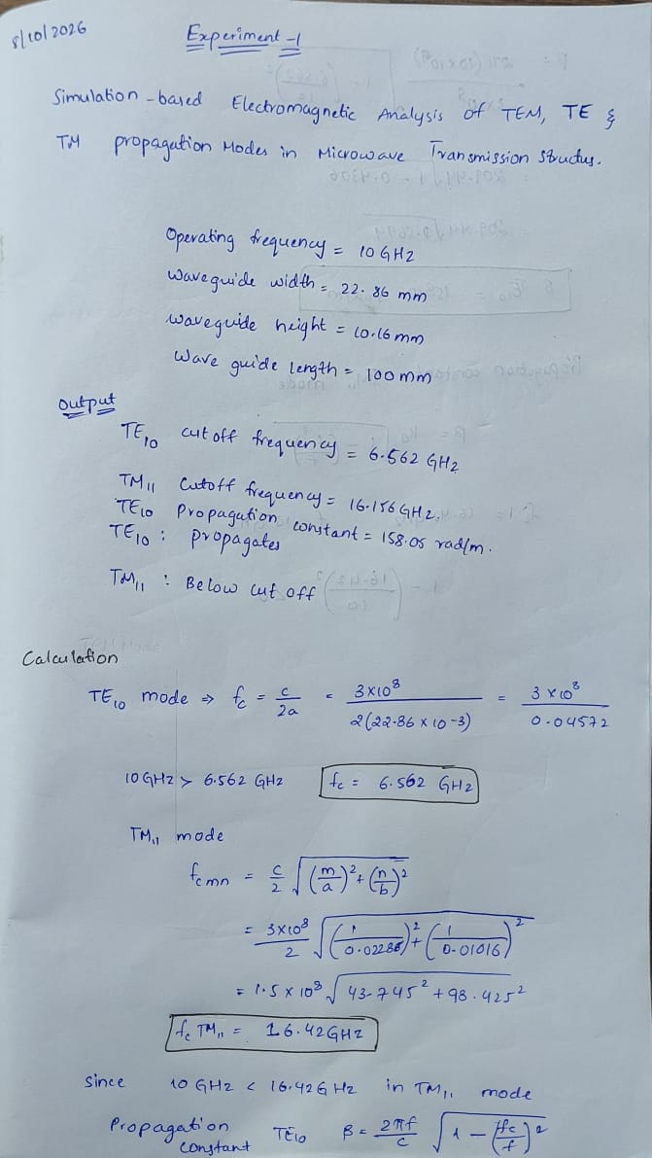

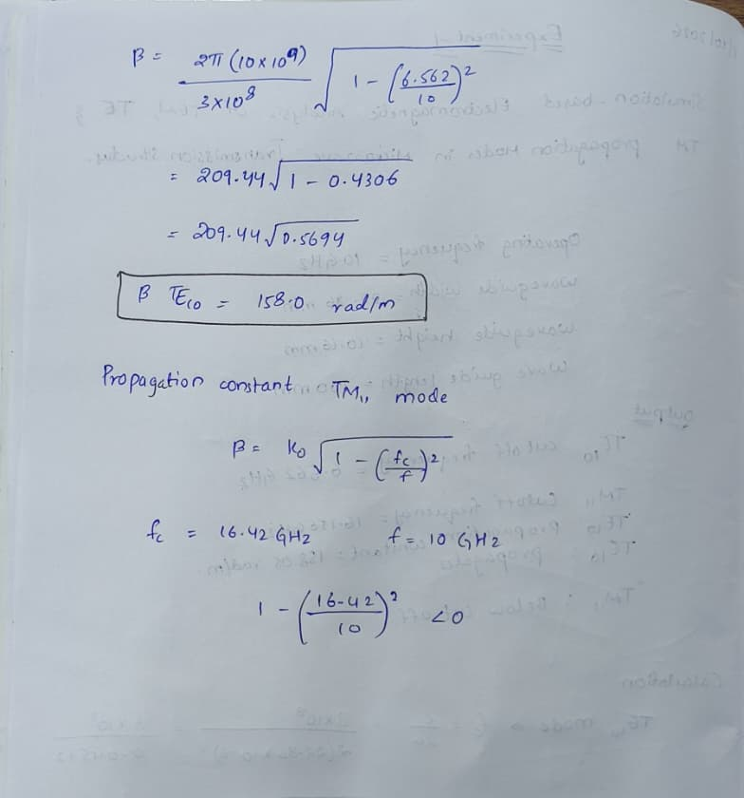

Results
For an air-filled WR-90 rectangular waveguide with a = 22.86 mm and b = 10.16 mm at 10 GHz, the TE10 cutoff frequency is approximately 6.562 GHz, so the dominant TE10 mode propagates. The TM11 cutoff frequency is approximately 16.42 GHz, so TM11 is below cutoff at 10 GHz. The TE10 propagation constant is approximately 158 rad/m and its guide wavelength is approximately 39.8 mm. A TEM mode cannot propagate in a hollow single conductor rectangular waveguide. These results agree with the expected mode behavior under the stated ideal assumptions.

GITHUB LINK
https://github.com/192412378simats-code/ECA1303

